INDEX

Sr. No. | Date | Title | Pg. No. | Sign
A |  | File System, Express, Promises and EJS
1 |  | CRUD Operations on JSON File using File System Module
2 |  | REST API for User Management using Express
3 |  | Custom Events using EventEmitter
4 |  | Fetching External API Data using Promises and Error Handling
5 |  | Dynamic HTML Pages using Express and EJS
B |  | Application Building using ES6
1 |  | ES6 Modules, Arrow Functions and Default Parameters
2 |  | Fetching API Data using Async/Await
3 |  | REST API with Query Parameters and Validation using ES6
4 |  | Transpiling ES6 Code using Babel
5 |  | Dynamic Dashboard using Express and EJS
6 |  | Dashboard Application with REST API, EJS and ES6
C |  | Client-Server Interaction using Socket.io and Redis
1 |  | Real-Time Chat Application using Socket.io and MongoDB
2 |  | Multi-Room Chat Application using Socket.io and MongoDB
3 |  | Real-Time Location Sharing using Socket.io and MongoDB
4 |  | Message Delivery Acknowledgment using Socket.io
5 |  | Real-Time User Tracking using Socket.io
6 |  | Message Timestamps and Sorting in Chat Application
7 |  | Chat API using MongoDB and Redis Caching
D |  | Testing Node.js Applications
1 |  | Basic Mocha and Chai Testing
2 |  | Testing Asynchronous Code using Mocha and Chai
3 |  | Testing Express Application using Supertest
4 |  | Mocha Setup and Teardown Hooks
5 |  | Testing Express Authentication using Mocha, Chai and Supertest
6 |  | Mocking Functions using Sinon
7 |  | Testing Task Application using Mocha, Chai and Supertest

ASSIGNMENT 1: FILE SYSTEM, EXPRESS, PROMISES AND EJS
QUESTION 1:
Develop a Node.js application that performs CRUD operations (Create, Read, Delete) on a JSON file using the File System module. The application should allow adding a new user, displaying all users, and deleting a user by ID.
Hints:
- Use fs.readFileSync() and fs.writeFileSync()
- Use JSON.parse() and JSON.stringify()
Handle file not found using try-catch
Code:
const fs = require("fs");
const fileName = "users.json";
function readUsers() {
try {
const data = fs.readFileSync(fileName, "utf8");
return JSON.parse(data);
} catch (err) {return [];}
}
function saveUsers(users) { fs.writeFileSync(fileName, JSON.stringify(users, null, 2));}
function addUser(id, name) {const users = readUsers();
users.push({id,name});
saveUsers(users);
console.log("User Added Successfully");
}
function displayUsers() {
const users = readUsers();
console.log(users);
}
function deleteUser(id) {
const users = readUsers();
const updatedUsers = users.filter(user => user.id !== id);
saveUsers(updatedUsers);
console.log("User Deleted");
}
addUser(1, "Rahul");
addUser(2, "Amit");
displayUsers();
deleteUser(1);
displayUsers();

OUTPUT:
PS D:\msc sem3\practical\303\file-code\unit 1\q1> node app.js
User Added Successfully
User Added Successfully
[ { id: 2, name: 'Amit' }, { id: 1, name: 'Rahul' },{ id: 2, name: 'Amit' }]
User Deleted
[ { id: 2, name: 'Amit' }, { id: 2, name: 'Amit' } ]
QUESTION 2:
Create an Express-based REST API that handles user data with the following routes:
GET /users, POST /users, PUT /users/:id, DELETE /users/:id. Use JSON for data exchange and implement proper request handling.
Hints:
- Use express() and app.use(express.json())
- Use req.body for POST/PUT
- Use req.params.id for DELETE/PUT
Store data in array or JSON file
Code:
const express = require("express");
const app = express();
app.use(express.json());
let users = [{ id: 1,name: "Anya"},{id: 2,name: "Alia"}];
app.get("/users", (req, res) => res.json(users);});
app.post("/users", (req, res) => {
const newUser = req.body;
users.push(newUser);
res.json({message: "User Added",
user: newUser});
});
app.put("/users/:id", (req, res) => {
const id = parseInt(req.params.id);
const user = users.find(u => u.id === id);
if (!user) {
return res.status(404).json({message: "User Not Found"});
}
user.name = req.body.name;
res.json({message: "User Updated", user});
});
app.delete("/users/:id", (req, res) => {
const id = parseInt(req.params.id);
users = users.filter(user => user.id !== id);
res.json({message: "User Deleted"});
});
const PORT = 3000;
app.listen(PORT, () => {console.log(`Server running on port ${PORT}`);});
OUTPUT:
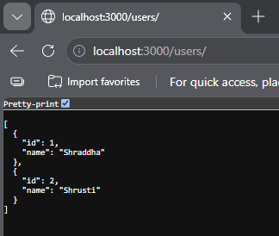
QUESTION 3:
Create a Node.js application using EventEmitter where a custom event (e.g., userLogin) is emitted and handled. The listener should display the username along with the timestamp when the event occurs.
Hints:
- Import using require('events')
- Use emitter.on() and emitter.emit()
- Pass username as argument
Use new Date() for timestamp
Code:
const EventEmitter = require("events");
const emitter = new EventEmitter();
emitter.on("userLogin", (username) => {
console.log(`User: ${username}`);
console.log(`Login Time: ${new Date()}`);
});
emitter.emit("userLogin", "Shraddha");
OUTPUT:
PS D:\msc sem3\practical\303\file-code\unit 1\q3> node app.js
User: Shraddha
Login Time: Tue Sep 1 2026 20:51:49 GMT+0530 (India Standard Time)

QUESTION 4:
Write a Node.js program to fetch data from an external API using Promises. Implement proper error handling for HTTP status codes such as 404 and 500.
Hints:
- Use fetch() or axios
- Check res.ok or res.status
- Use .then() and .catch()
- Convert response using res.json()

Code:
const url = "https://jsonplaceholder.typicode.com/users";

fetch(url)
.then((res) => {
if (!res.ok) {
if (res.status === 404) {throw new Error("Error 404: Data Not Found");}
if (res.status === 500) {throw new Error("Error 500: Internal Server Error");}
throw new Error(`HTTP Error: ${res.status}`);
}
return res.json();
})
.then((data) => {
const users = data.slice(0, 2);
console.log("Data fetched successfully:");
console.log(users);
})
.catch((err) => {console.log("Error:", err.message);});
OUTPUT:
PS D:\msc sem3\practical\303\file-code\unit 1\q4> node app.js
Data fetched successfully:
[
{
id: 1,
name: 'Leanne Graham',
username: 'Bret',
email: 'Sincere@april.biz',
address: {
street: 'Kulas Light',
suite: 'Apt. 556',
city: 'Gwenborough',
zipcode: '92998-3874',
geo: [Object]
},
phone: '1-770-736-8031 x56442',
website: 'hildegard.org',
company: {
name: 'Romaguera-Crona',
catchPhrase: 'Multi-layered client-server neural-net',
bs: 'harness real-time e-markets'
}
},
{
id: 2,
name: 'Ervin Howell',
username: 'Antonette',
email: 'Shanna@melissa.tv',
address: {
street: 'Victor Plains',
suite: 'Suite 879',
city: 'Wisokyburgh',
zipcode: '90566-7771',
geo: [Object]
},
phone: '010-692-6593 x09125',
website: 'anastasia.net',
company: {
name: 'Deckow-Crist',
catchPhrase: 'Proactive didactic contingency',
bs: 'synergize scalable supply-chains'
}
}
]

QUESTION 5:
Develop an Express application that uses EJS as a template engine to render dynamic HTML pages. Pass user data from the server and display it on the frontend.
Hints:
- Install EJS → npm install ejs
- Use app.set('view engine', 'ejs')
- Use res.render() to send data
- Display using <%= %> in EJS
Code:
- App.js
const express = require("express");
const app = express();
app.set("view engine", "ejs");
const user = { name: "Shraddha",age: 21, city: "Valsad"};
app.get("/", (req, res) => { res.render("index", { user: user});});
app.listen(3000, () => {
console.log("Server running on port 3000");
});

- Index.ejs

<!DOCTYPE html>
<html>
<head>
<title>User Details</title>
</head>
<body>
<h1>User Information</h1>
<p>Name: <%= user.name %></p>
<p>Age: <%= user.age %></p>
<p>City: <%= user.city %></p>
</body>
</html>

OUTPUT:
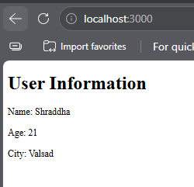

ASSIGNMENT 2: APPLICATION BUILDING USING ES6

Question 1.
Create a Node.js application using ES6 features. Develop a module mathUtils.js that defines functions for addition and subtraction using arrow functions. Use const and let appropriately and include default parameters. Export these functions using ES6 module syntax.
In another file app.js, import the module and display the results in the console.
CODE:
- Package.json
{
"name": "q1",
"version": "1.0.0",
"description": "",
"main": "index.js",
"type": "module",
"scripts": {
"test": "echo \"Error: no test specified\" && exit 1"
},
"keywords": [],
"author": "",
"license": "ISC"
}
- mathUtils.js
const add = (a = 0, b = 0) => { return a + b;};
const subtract = (a = 0, b = 0) => { return a - b;};
const multiply = (a = 1, b = 1) => { return a * b;};
const divide = (a = 1, b = 1) => { return a / b;};
export { add, subtract, multiply, divide };
- app.js
import { add, subtract, multiply, divide } from "./mathUtils.js";
let num1 = 20;
let num2 = 10;
const addition = add(num1, num2);
const subtraction = subtract(num1, num2);
const multiplication = multiply(num1, num2);
const division = divide(num1, num2);
console.log("Addition:", addition);
console.log("Subtraction:", subtraction);
console.log("Multiplication:", multiplication);
console.log("Division:", division);

OUTPUT:
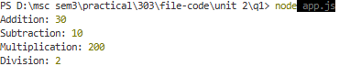

Question 2.
Write a Node.js program that fetches data from an external API using the built-in fetch (Node.js v18+). Use async/await to handle asynchronous operations and implement proper error handling using try/catch.
Display selected fields (e.g., name and email) from the API response in the console.
CODE:
const url = "https://jsonplaceholder.typicode.com/users";
async function getUsers() {
try {
const response = await fetch(url);
if (!response.ok) {
throw new Error(`HTTP Error: ${response.status}`);
}
const data = await response.json();
data.forEach(user => {
console.log("Name:", user.name);
console.log("Email:", user.email);
console.log("----------------");
});
} catch (error) {
console.log("Error:", error.message);
}
}
getUsers();
OUTPUT:
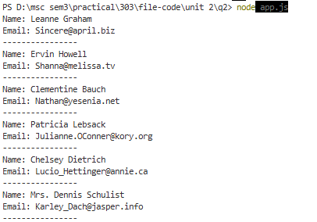
Question 3.
Develop a Node.js REST API using Express and ES6 syntax. Create a GET endpoint /user that accepts query parameters name and age.Validate that age is greater than 18, If valid, return a JSON response with a welcome message ,If invalid, return an appropriate error message with HTTP status code
CODE:
const express = require("express");
const app = express();
app.get("/user", (req, res) => {
const name = req.query.name;
const age = parseInt(req.query.age);
if (!name || isNaN(age)) {
return res.status(400).json({message: "Please provide valid name and age"});
}
if (age <= 18) {
return res.status(400).json({message: "Age must be greater than 18"});
}
res.json({message: `Welcome ${name}`,age: age});
});
const PORT = 3000;
app.listen(PORT, () => {console.log(`Server running on port ${PORT}`);});
OUTPUT:
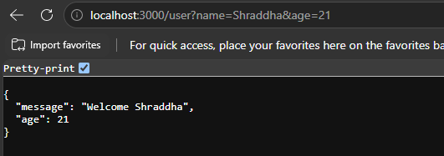

Question 4.
Create a Node.js program using modern ES6 features such as arrow functions, default parameters, and const/let. Configure Babel in your project and transpile the ES6 code into ES5.
Show: Original ES6 code ,Transpiled ES5 output ,Brief explanation of how Babel converts the code
CODE:
Src/app.js:
const greet = (name = "Student") => { return `Hello, ${name}!`;};
let number = 10;
const square = (n = 1) => { return n * n;};
console.log(greet("Shraddha"));
console.log("Number:", number);
console.log("Square:", square(number));
then after that run:
src/app.js:
- node src/app.js
then for babel:
- npx babel src --out-dir dist
- node dist/app.js
STRUCTURE:
q4/
│
├── src/
│ └── app.js
│
├── dist/
│ └── app.js
│
├── babel.config.json
├── package.json
├── package-lock.json
└── node_modules/
OUTPUT:
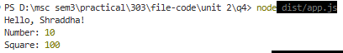

Question 5.
Develop a Node.js application using Express and EJS templating engine. Create a route /dashboard that renders a dynamic HTML page.Define a list of users in the server,Pass the data to the EJS template,Display the user details dynamically using EJS syntax
CODE:
- app.js
import express from "express";
const app = express();
app.set("view engine", "ejs");
const users = [
{id: 1,name: "Riya",email: "riya@gmail.com",age: 21},
{id: 2,name: "Amit",email: "amit@gmail.com",age: 22},
{id: 3, name: "Shraddha",email: "shraddha@gmail.com",age: 21}
];
app.get("/dashboard", (req, res) => { res.render("dashboard", { users: users});});
const PORT = 3000;
app.listen(PORT, () => { console.log(`Server running on port ${PORT}`);});

- Dashboard.ejs:
<!DOCTYPE html>
<html>
<head>
<title>User Dashboard</title>
</head>
<body>
<h1>User Dashboard</h1>
<% users.forEach(user => { %>
<div>
<h2><%= user.name %></h2>
<p>ID: <%= user.id %></p>
<p>Email: <%= user.email %></p>
<p>Age: <%= user.age %></p>
</div>
<% }); %>
</body>
</html>

- Package.json:

{
"name": "q5",
"version": "1.0.0",
"description": "",
"main": "app.js",
"type": "module",
"scripts": {
"test": "echo \"Error: no test specified\" && exit 1"
},
"keywords": [],
"author": "",
"license": "ISC",
"dependencies": {
"ejs": "^6.0.1",
"express": "^5.2.1"
}
}

- STRUCTURE:
q5/
│
├── node_modules/
│
├── views/
│ └── dashboard.ejs
│
├── app.js
├── package.json
└── package-lock.json
OUTPUT:
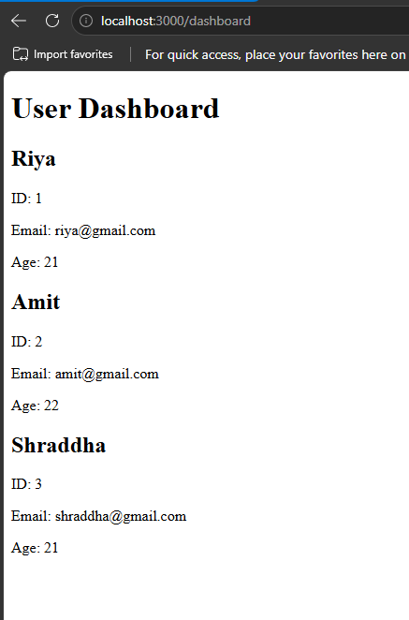

Question 6.
Create a complete Node.js application that includes:,A REST API endpoint /api/users returning JSON data, A route /dashboard that fetches this data internally and renders it using EJS,Use ES6 syntax throughout the application,Implement basic validation and error handling
CODE:
- Package.json
{
"name": "q6",
"version": "1.0.0",
"description": "",
"main": "index.js",
"type": "module",
"scripts": {
"test": "echo \"Error: no test specified\" && exit 1"
},
"keywords": [],
"author": "",
"license": "ISC",
"dependencies": {
"ejs": "^6.0.1",
"express": "^5.2.1"
}
}
- App.js
import express from "express";
const app = express();
app.set("view engine", "ejs");
const users = [
{id: 1,name: "Riya",email: "riya@gmail.com",age: 21},
{id: 2,name: "Amit",email: "amit@gmail.com",age: 22},
{id: 3,name: "Shraddha",email: "shraddha@gmail.com",age: 21}
];
app.get("/api/users", (req, res) => {
if (!users || users.length === 0) {
return res.status(404).json({message: "No users found"});
}
res.json(users);
});
app.get("/dashboard", async (req, res) => {
try {
const response = await fetch("http://localhost:3000/api/users");

if (!response.ok) {throw new Error("Failed to fetch users");}
const data = await response.json();
res.render("dashboard", {users: data});
} catch (error) {
console.log("Error:", error.message);
res.status(500).send("Error loading dashboard");
}
});
const PORT = 3000;
app.listen(PORT, () => {console.log(`Server running on port ${PORT}`);});
- Dashboard.js
<!DOCTYPE html>
<html>
<head>
<title>User Dashboard</title>
</head>
<body>
<h1>User Dashboard</h1>
<% if (users.length === 0) { %>
<p>No users found.</p>
<% } else { %>
<% users.forEach(user => { %>
<div>
<h2><%= user.name %></h2>
<p>ID: <%= user.id %></p>
<p>Email: <%= user.email %></p>
<p>Age: <%= user.age %></p>
</div>
<% }); %>
<% } %>
</body>
</html>

STRUCTURE:
q6/
│
├── views/
│ └── dashboard.ejs
│
├── app.js
└── package.json
OUTPUT:
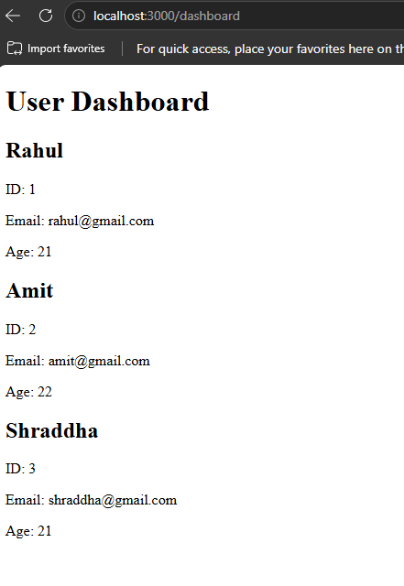

ASSIGNMENT 3:CLIENT-SERVER INTERACTION USING SOCKET.IO & REDIS

ASSIGNMENT 4: TESTING NODE.JS APPLICATIONS

